# Document for debug Nesjs in VSCode

Step 1: Add breakpoint for debugging

Step 2: Click debug feature of VSCode

Step 3: Click setting icon in top

Step 4: Config the launch.json to run debugging

{

"version": "0.0.1",

"configurations": [

{

"type": "node",

            "request": "launch",

            "name": "Launch NestJS",

            "runtimeExecutable": "npm",

            "runtimeArgs": ["run-script", "start:dev"],

            "port": 5000,

            "cwd": "${workspaceFolder}",

            "console": "internalConsole"

}

]

}

Add the config above for launch.json

Step 5: Stop program if it is running

Step 6: Go to application by access URL in local. eg. <http://localhost:3333>

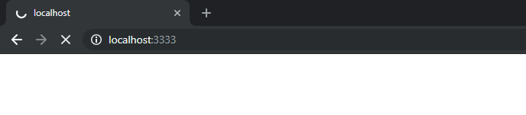

Step 7: Now, you can perform debbuging in VSCode very easy

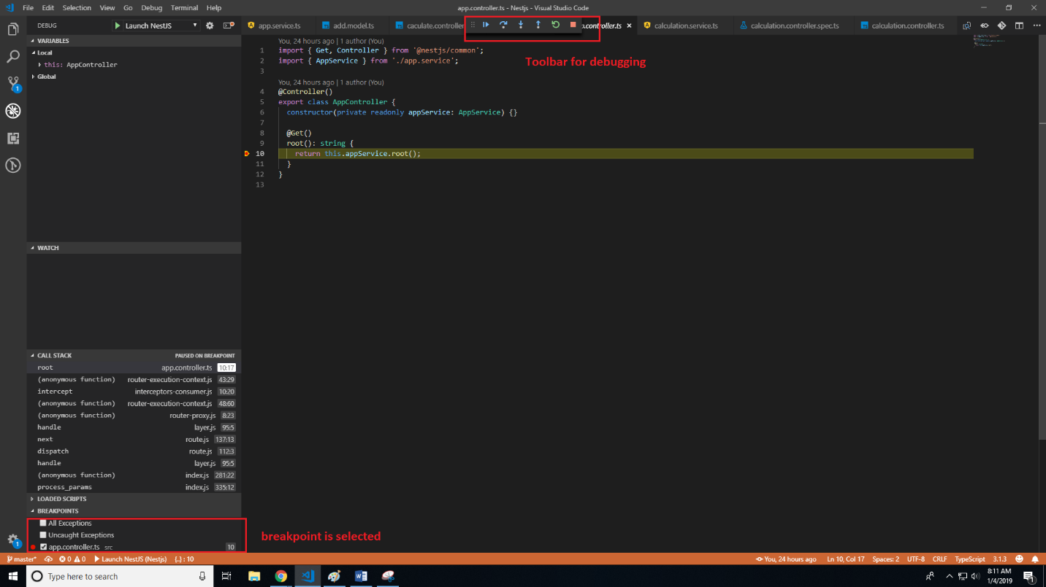

You can press:

F5: continue to next breakpoint

F10: step into

F11: step over

And more